Business Name and Address | Mount House Whitby  44 Cliff Street  Whitby  YO21 3DD
Type of Operation | - Small bed & breakfast type of establishment. 2 -3 bedrooms only, breakfast in the kitchen.  - Soap making, packing and shipping – taking place when no guests are booked in.  - Translation business
Services Provided | Overnight accommodation is provided along with use of a lounge and kitchen provision of breakfast and snacks, occasional other meals including packed lunch.
Name of Person Who Has Developed This Document | Ruth Denison

The hazard
SARS-CoV-2 is a respiratory virus that can invade a host via the respiratory route or via hand to eye / mouth / nose contact, causing the disease COVID-19.
People who may appear healthy may be carrying and shedding the virus, which can be passed on either directly or indirectly to others. This means we need to assume that anyone could be carrying the virus.
The routes of transmission (how the hazards can cause harm – the risks)
- Direct contact to face – eyes, nose from droplets or aerosols spraying from an infected person onto another person who is in close contact.
- Contamination via droplets from sneezing and coughing landing on surfaces and then transferring via hands on to eyes and nose and mouth, and then touching surfaces with contaminated hands.
- Contaminated hands of infected people can transfer the virus directly to others (e.g. handshakes) or on to hand contact surfaces which can be picked up bu other people’s hands and transferred to their eyes, nose or mouth.
- Possible transmission from faeces to hands and then directly or indirectly to the body via hands and hand contact surface transfer.
The main controls are:
- Social distancing in accordance with government guidelines
- Disinfecting hand contact surfaces
- Hand washing and hand sanitiser use at key moments
- No touching eyes, mouth or nose with contaminated fingers
The controls set out in this document will be specific for this operation, that is the bed and breakfast leg of the business, taking into account how the guests and host use the premises and interact.
Example of a guest journey flow diagram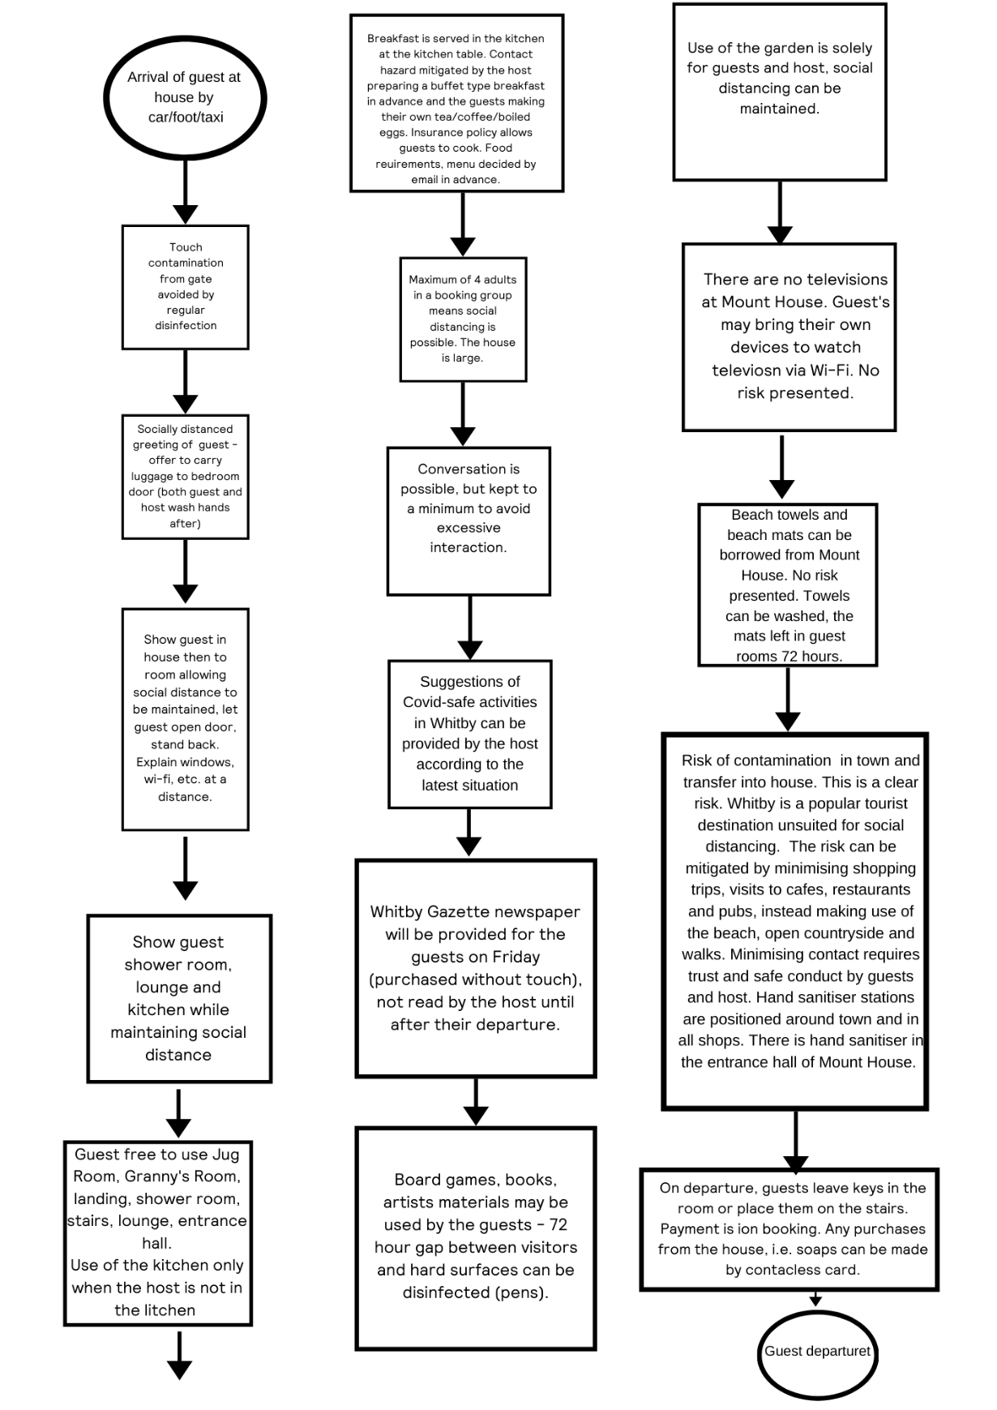

Prerequisites

ITEM | OR CONTROL
Disinfection | Use of diluted bleach to disinfect surfaces, touch points and floors.
Ventilation | The house is draughty, ventilation is manual via the large number of windows.
Hand hygiene | Frequent hand washing with soap and water or hand sanitiser at the front door to be used upon entry and leaving, if wished
Social distancing goal | Vigilance is required within the house, but distancing is quite possible due to the size of the property.
Guest capacity | Maximum 4 adult guests, or 4 adults and 3 infants/small children who can share their parents’ bedroom absolute maximum.

Please also see our Mount House Whitby Covid-19 Cleaning Plan.
In the event of suspected guest infection.
- If a guest cannot reasonably return home (for example because they are not well enough to travel or do not have the means to arrange transport), their circumstances should be discussed with an appropriate health care professional and, if necessary, the local authority. Guests should follow government guidance on dealing with possible or confirmed coronavirus (COVID-19) infection. Once the guest has returned to their main residence, they should continue to follow the government guidance on self-isolation, household isolation and social distancing.
- This will apply to all guests that were present in the room. If the guest shows acute symptoms has breathing difficulties or their life is at potential risk, medical help will be sought immediately.
- A professional cleaning company will be contracted, and all guests with reservations in the near future will be notified.

In the event of a suspected host infection during a stay
- Guests should return to their main residence and follow the government guidance on self-isolation, household isolation and social distancing.
- All further bookings will be cancelled as required by government guidance.

Booking limitations and guest numbers
The two guest bedrooms will be let as a single unit to one household group or bubble group. This is to minimise the risk of cross contamination.
The guests can rest assured that they will be the only guests in the house for the duration of the stay.

Additional business legs
The soap-making and translation legs of the business do not involve person-to-person contact, apart from delivery personnel and visits to the post office to ship goods.
Post office visits can be minimised by contracting collection shipping companies, should the volume of shipments make that appropriate.
Soapmaking is only conducted when no guests are booked in. Light administrative tasks may be carried out while guests are in the house like packing and paperwork, weighing the soaps. These do not affect the guests or increase person-to-person contact.
Translation work is undertaken in the host’s office and does not involve any person-to-person contact. This work may be continued when guests are in the house without incurring any additional risk.

